Subject Name: **Source Code Management**

Subject Code: **22CS003**

Session: **2022-23**

Department: **DCSE**



|  |  |  |
| --- | --- | --- |
| **Submitted By:**  Charvi Bansal  2210990236  G21-B |  | **Submitted To:**  Ms. Preeti Saini |

**List of Programs**

|  |  |  |
| --- | --- | --- |
| **S. No** | **Program Title** | **Page No.** |
| 1 | Setting up of Git Client | 3-5 |
| 2 | Setting up GitHub Account | 6-8 |
| 3 | Generate logs | 9-11 |
| 4 | Create and visualize branches |  |
| 5 | Git life cycle description |  |
| 6 | Add collaborators on GitHub Repo |  |
| 7 | Fork and Commit |  |
| 8 | Merge and Resolve conflicts created due to own activity and collaborators activity. |  |
| 9 | Reset and revert |  |
|  |  |  |
|  |  |  |
|  |  |  |
|  |  |  |

Experiment-1

**Aim:** Setting up git client

**Theory**: Version control system is a software tool that is used to record the changes that we made in a code. One of the most well-known and effective version control systems is the git client. Git Gui is primarily concerned with enabling users to edit their repository by adding new commits or editing old ones to remote repositories. Like gitk, the Git GUI does not display project history.

**Procedure:**

Git can be installed on a variety of software platforms using a variety of approaches.

For Linux, a binary installer can be used.

Usually, the package management tool handles it. You can use dnf as one method.

Go to the git website if you're using Windows. Install git for Windows is an alternative, or you can click the following link: https://git-scm.com/download/win.

Installing the Xcode Command Line tools is the simplest way to install git on a mac.

**Snapshots:**

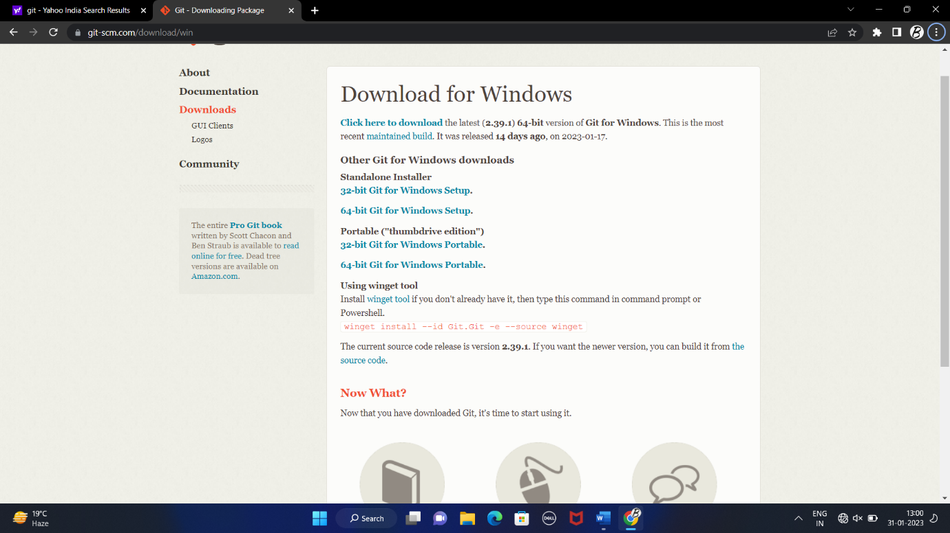

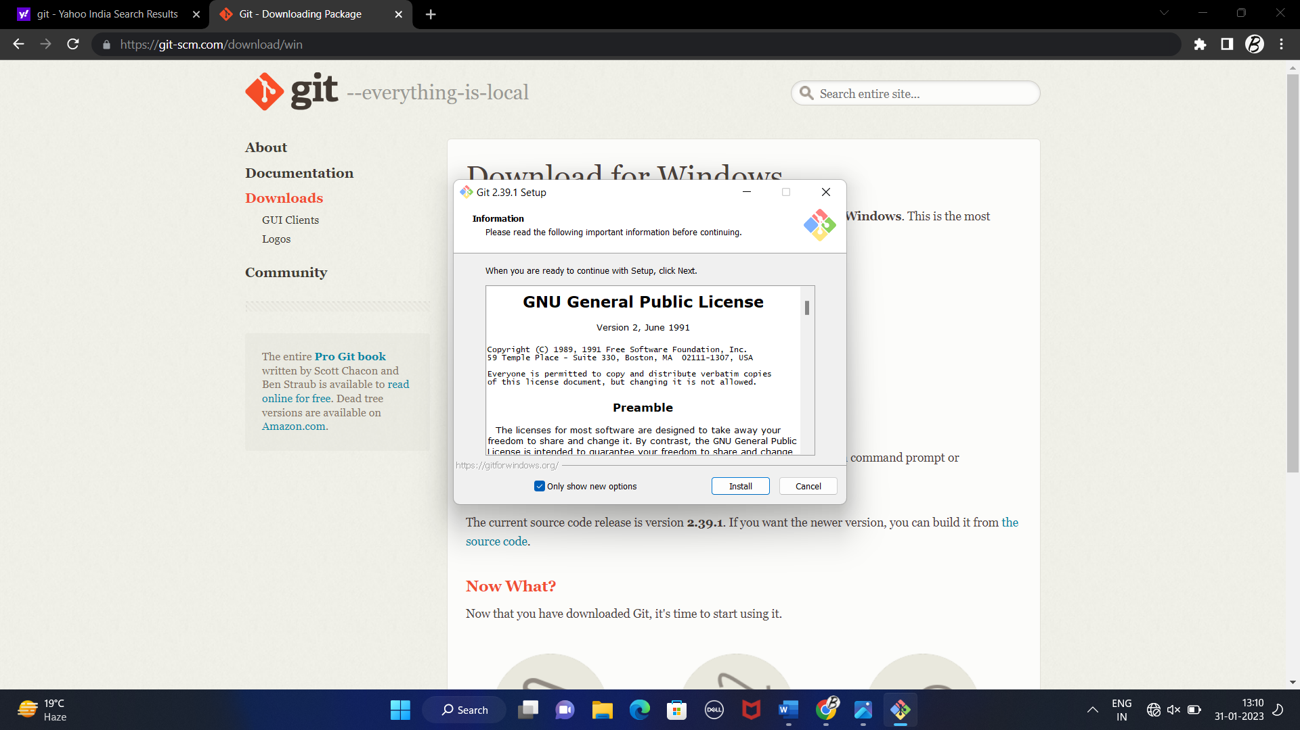**Opted for “64-bit Git for Windows Setup.”**

Git setup

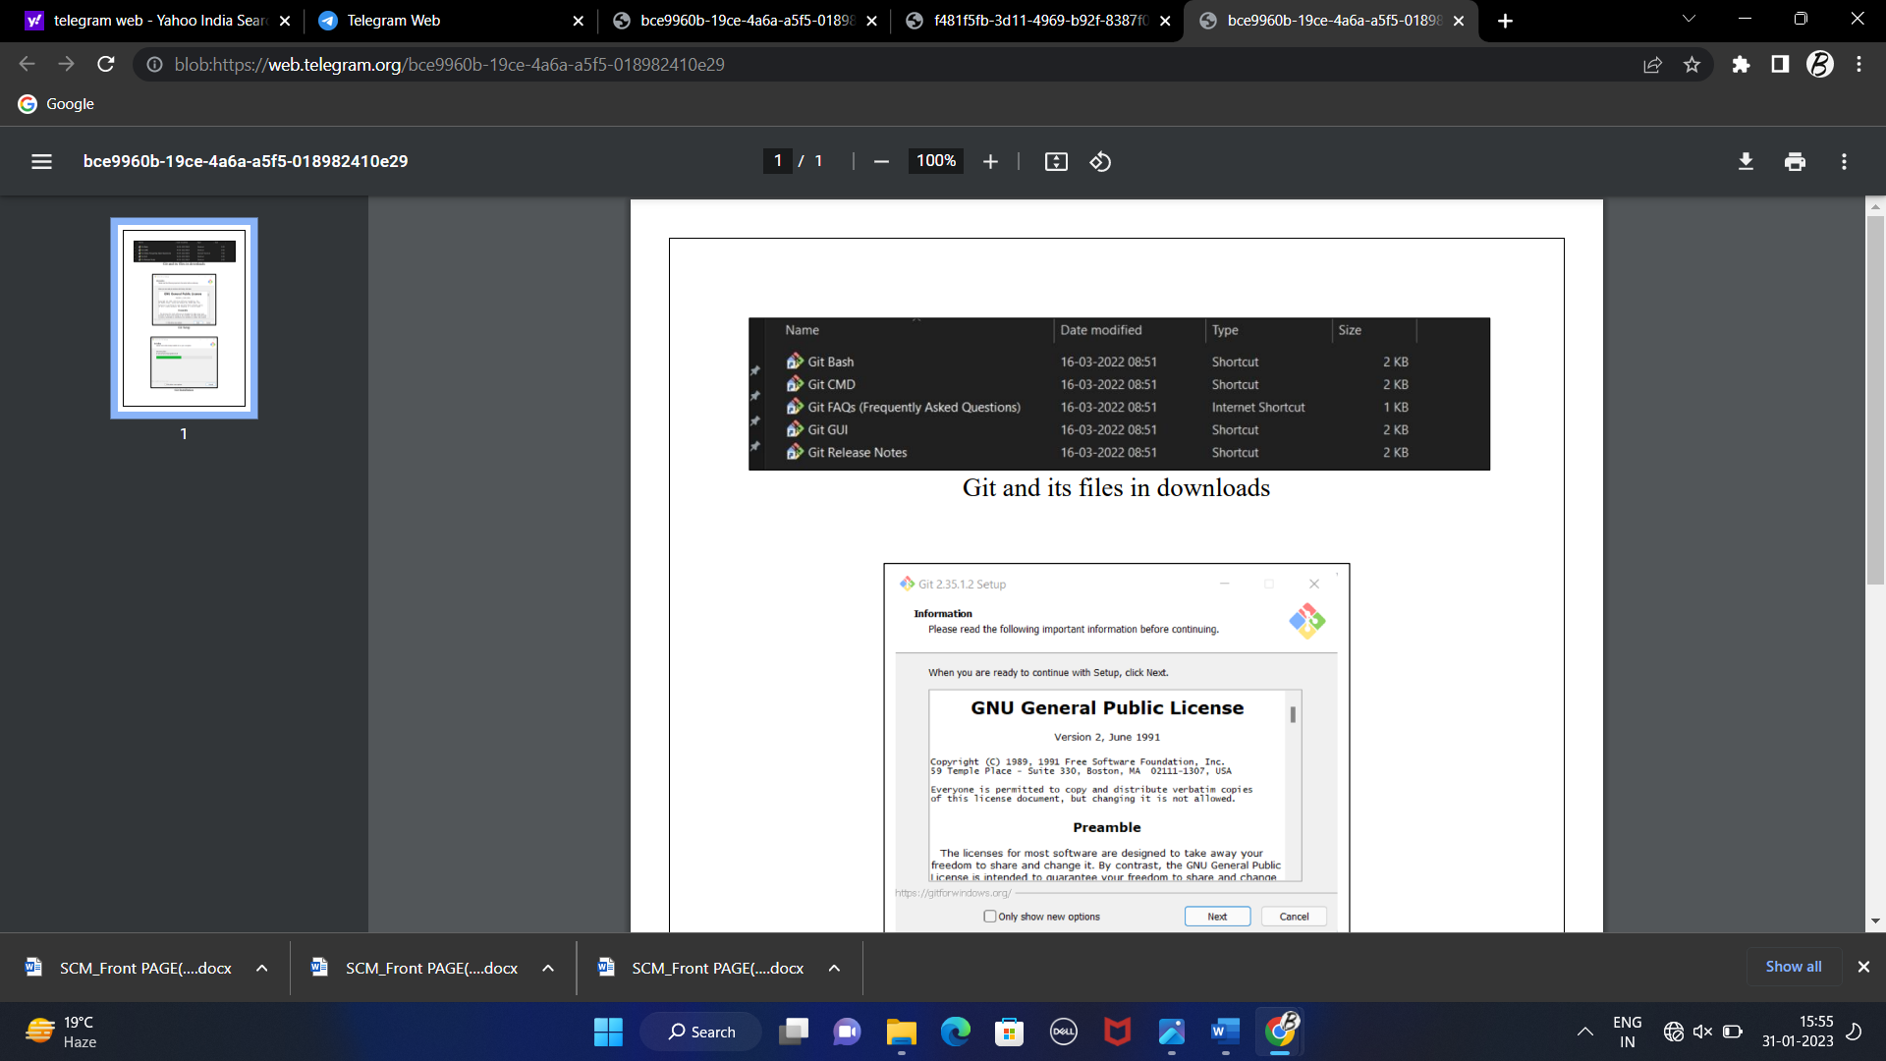

**Git and its files in download**

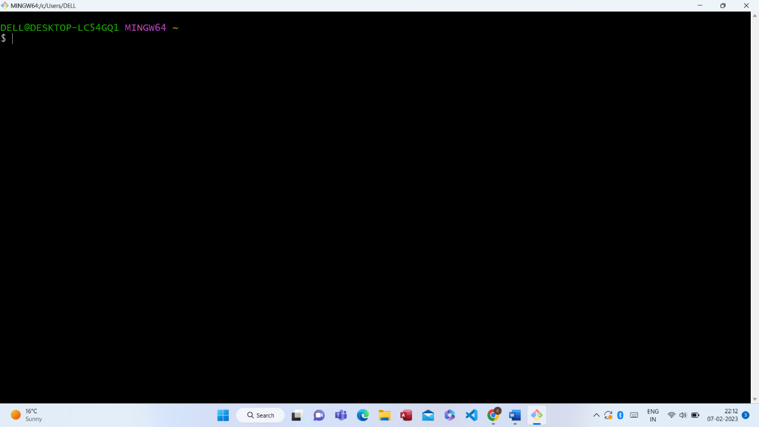

Git bash launched

Experiment-2

**Aim**: Setting up git hub account

**Theory**: GitHub CLI is an open-source tool for using GitHub from your computer's command line. When you're working from the command line, you can use the GitHub CLI to save time and avoid switching context.

If you plan to use Git locally on your computer, whether through the command line, an IDE or text editor, you will need to install and set up Git. For more information, see "[Set up Git](https://docs.github.com/en/get-started/quickstart/set-up-git)." If you prefer to use a visual interface, you can download and use GitHub Desktop. GitHub Desktop comes packaged with Git, so there is no need to install Git separately.

**Procedure:** It Hub can be found by performing an internet search for it. Go to https://github.com/signup, the official website. Choose a username and password, then type in your mail ID. If you don't already have one, create one now; else, use your login information. By solving a simple puzzle while joining up, you must prove you're a human and not a robot.

**Snapshots:**

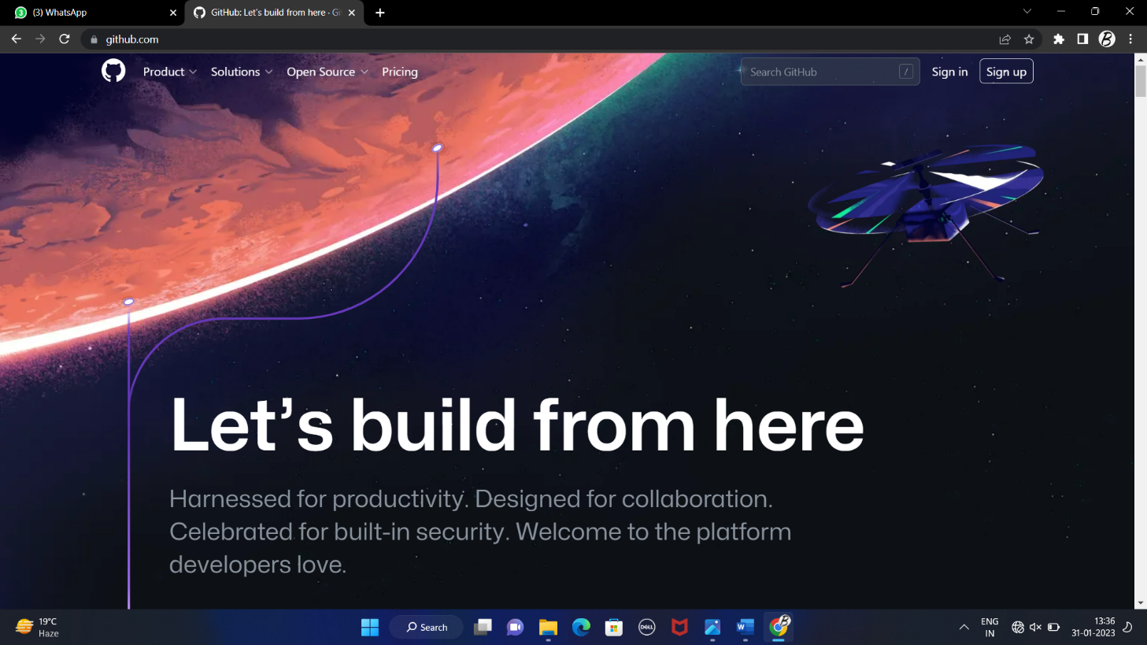

**GitHub Homepage**

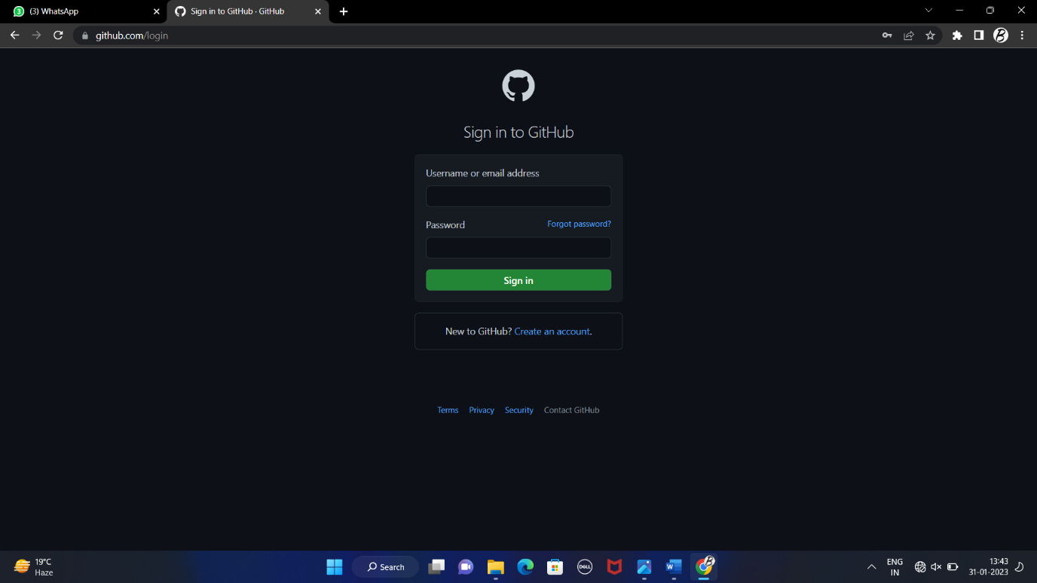

**GitHub Login Page**

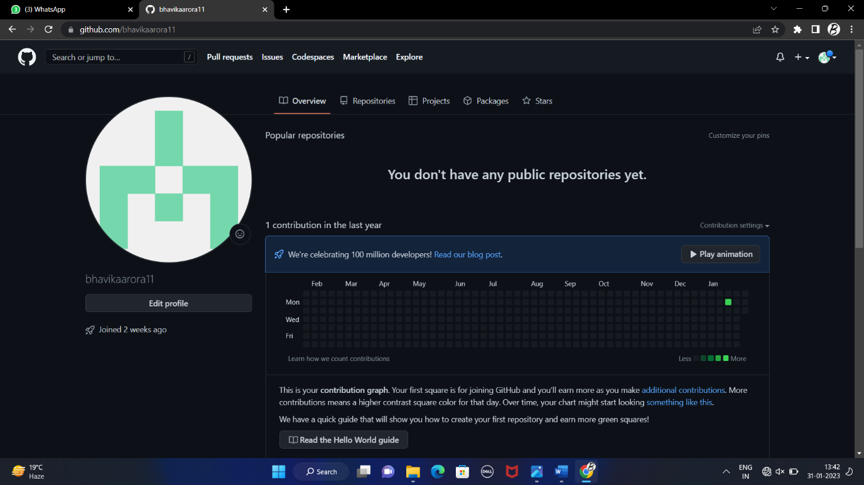

**GitHub Profile Page**

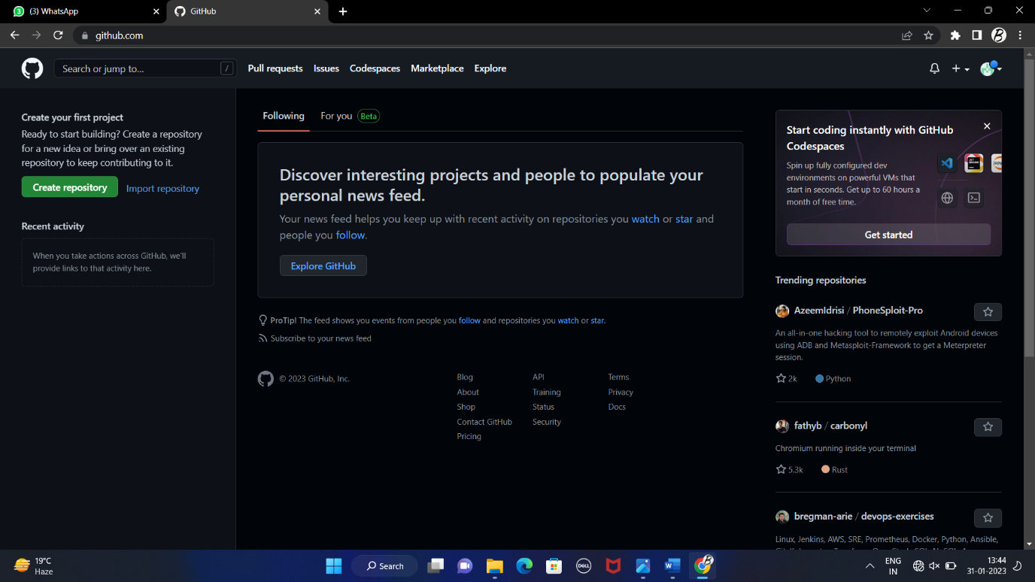

**GitHub Homepage**

Experiment-3

**Aim**: Program to generate log

**Theory**: Log files are the major source of data for network monitoring. A log file is a type of data file created by a computer that provides information about usage patterns, activities, and processes within an operating system, application, server, or other device. Log files demonstrate how well-functioning and appropriate resource usage is.

**Procedure:** Start by using git to create an empty repository. Open the terminal on your Mac to create a repository. Give git init a pass. A local repository is made as a result.

To access Git later and make modifications, if necessary, you must enter your login and email when using it for the first time.

If you have chosen to make your account public, then any changes you make will be available to everyone.

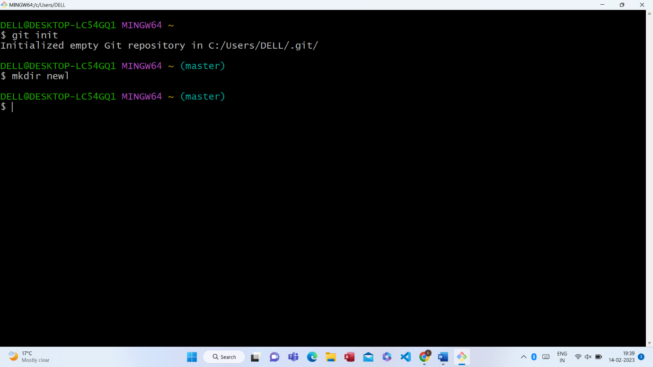

For this, we use the following commands:

* “git config--global user.name Name”
* “git config--global user.email email”

To verify the username and email, we use the following commands:

* “git config--global user.name”
* “git config--global user.email”

In git, you can also check the status of the file using git status.

***SOME OTHER IMPORTANT COMMANDS***

* history →All the commands that have been used on the cell previously will be displayed
* ls →It will display all the directories and files and folders on the system
* ls -l →It will display all the information regarding file and folders on the system
* ls-F →It will display the backlash with the directories in the system.
* mkdir new1 →It makes a new dictionary.
* cd new1 →It changes the present directory to a new one.
* cd →It goes back to the root directory or home directory.
* touch try1.txt →It creates a new blank file.
* whoami →It displays the id of the current user.
* pwd →It displays the resent working directory.

